**1. ReactJS-HOL**

node -v

npm –v

npm install -g create-react-app

npx create-react-app myfirstreact

cd myfirstreact

code .

**App.js**

import React from 'react';

function App() {

return (

<div>

<h1>Welcome to the first session of React</h1>

</div>

);

}

export default App;

npm start

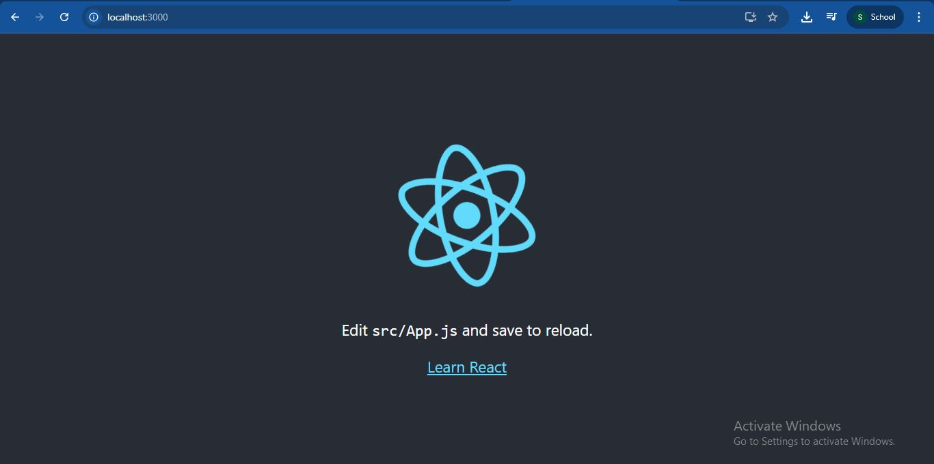



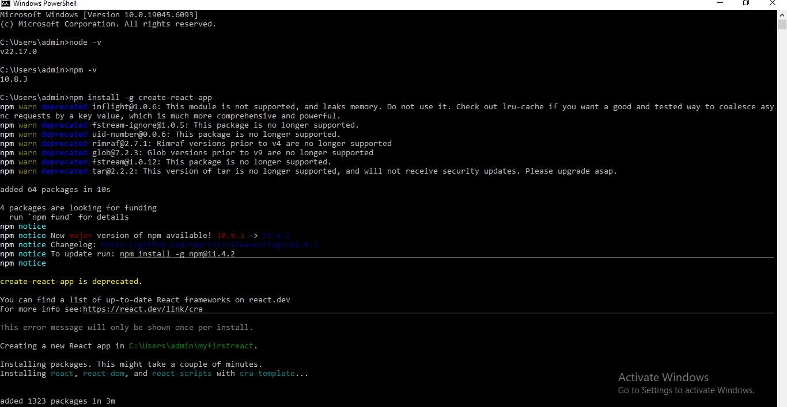

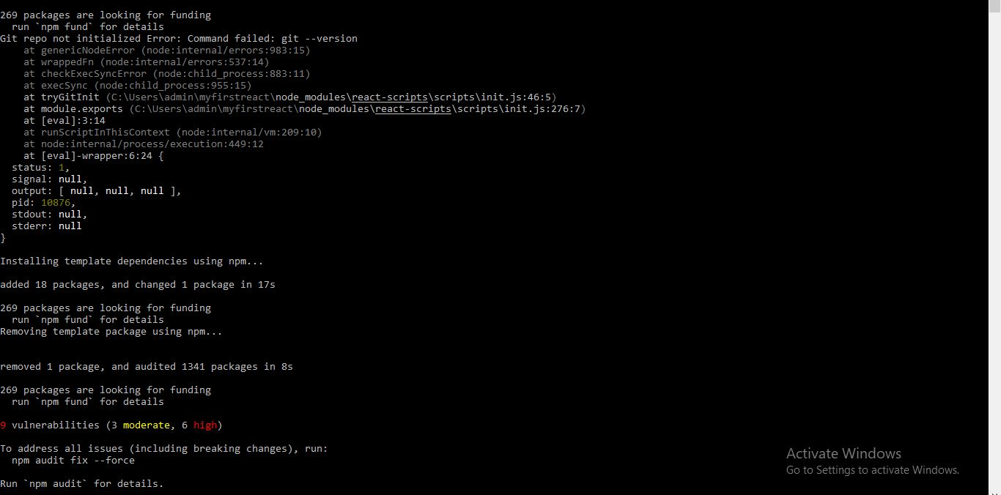

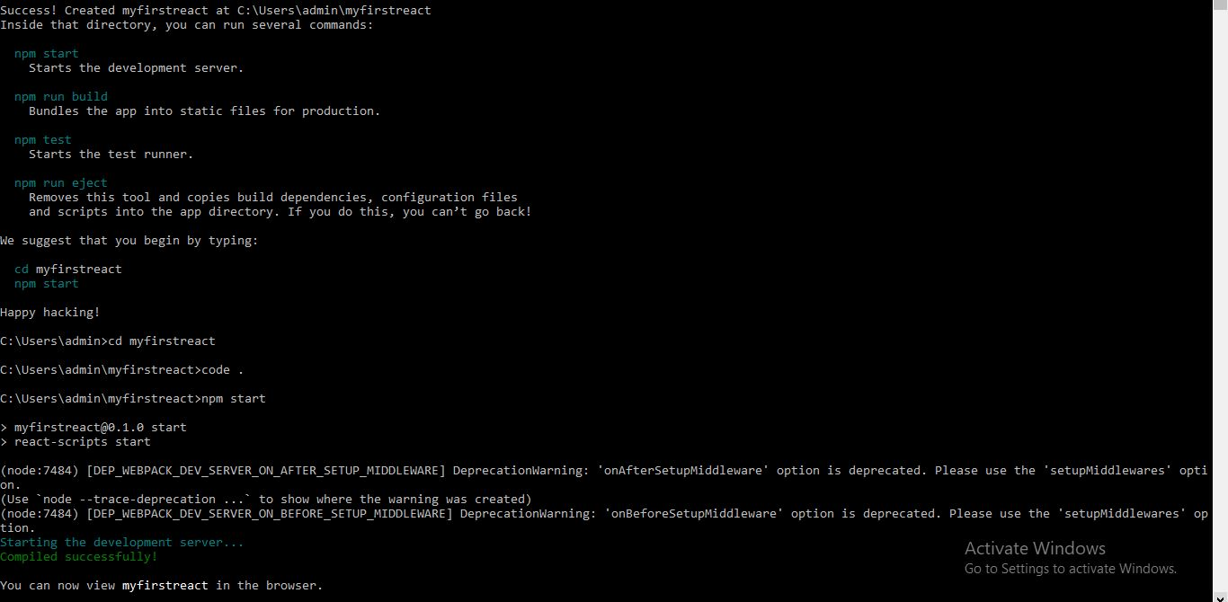

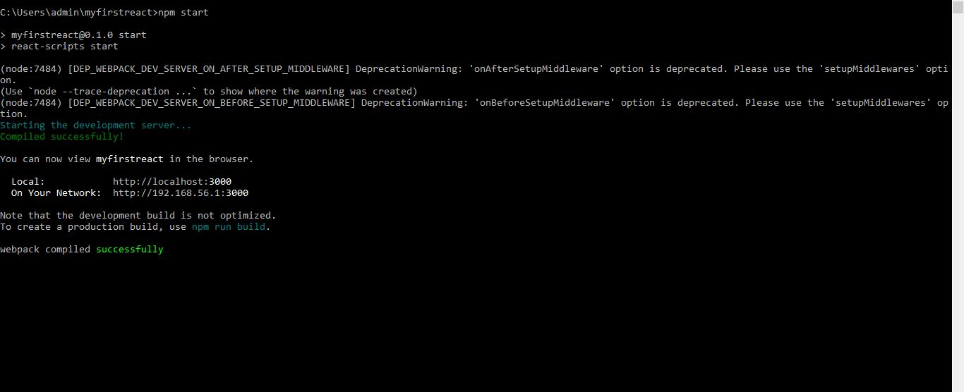

**1. Define SPA and its benefits**

**SPA (Single Page Application)** is a web application that interacts with the user by dynamically rewriting the current page, rather than loading entire new pages from the server. This means the application loads a single HTML page and updates content as needed via JavaScript.

**Benefits of SPA:**

* Faster navigation as there is no full-page reload.
* Improved user experience with smooth transitions.
* Reduces server load after initial load.
* Frontend code can be reused across views.

**2. Define React and identify its working**

**React** is an open-source JavaScript library developed by Facebook for building user interfaces, especially single-page applications.

**How React Works:**

* React uses a component-based architecture to build reusable UI elements.
* It uses a virtual DOM to efficiently update and render components.
* When the data changes, React updates only the affected parts of the DOM, improving performance.

**3. Identify the differences between SPA and MPA**

| **Feature** | **SPA (Single Page Application)** | **MPA (Multi Page Application)** |
| --- | --- | --- |
| Page Reload | No | Yes |
| Speed | Fast after initial load | Slower due to full page reloads |
| Development | Uses frameworks like React, Angular | Uses traditional methods (JSP, PHP, etc.) |
| SEO Support | Limited without Server-Side Rendering | Better SEO support |
| Browser Navigation | Requires additional setup for routing | Handled by server automatically |

**4. Explain Pros and Cons of Single-Page Application**

**Pros:**

* Improved user experience with seamless transitions.
* Faster page loads after initial load.
* Easier to debug using browser developer tools.
* Good for responsive mobile web applications.

**Cons:**

* Poor SEO without server-side rendering.
* Initial load time may be longer.
* Requires JavaScript to be enabled in the browser.
* Browser history and navigation need to be managed manually.

**5. Explain about React**

React is a JavaScript library used to build user interfaces in a component-based approach. It is designed to make the process of building modular, scalable, and fast user interfaces easier. It promotes the use of reusable components, making development more efficient.

React focuses on the "view" part of the MVC (Model-View-Controller) architecture and can be integrated with other libraries or frameworks for state management and routing.

**6. Define Virtual DOM**

The **Virtual DOM** is a lightweight in-memory representation of the actual DOM in a browser. When the state of a component changes, a new virtual DOM is created and compared with the previous one using a process called "diffing."

Only the differences are then applied to the real DOM. This makes the UI updates more efficient and faster, enhancing application performance.

**7. Explain Features of React**

Key features of React include:

* **Component-Based**: UI is divided into reusable components.
* **JSX**: JavaScript XML allows writing HTML-like syntax in JavaScript.
* **Virtual DOM**: Efficient updates by minimizing direct DOM manipulations.
* **Unidirectional Data Flow**: Data flows from parent to child components, making code predictable.
* **Declarative UI**: Describe what you want to render, and React will handle the rendering.